CITY OF NANAIMO

BYLAW NO. 6500.025

A BYLAW TO AMEND THE CITY OF NANAIMO
“OFFICIAL COMMUNITY PLAN BYLAW 2008 NO. 6500”

WHEREAS the Council of the City of Nanaimo wishes to amend City of Nanaimo “OFFICIAL COMMUNITY PLAN BYLAW 2008 NO. 6500”;

THEREFORE, BE IT RESOLVED that the Municipal Council of the City of Nanaimo, in open meeting assembled, ENACTS AS FOLLOWS:

- This Bylaw may be cited as the “OFFICIAL COMMUNITY PLAN AMENDMENT BYLAW 2014 NO. 6500.025”.

2. The City of Nanaimo “OFFICIAL COMMUNITY PLAN BYLAW 2008 NO. 6500” is hereby amended as set out in Schedules A and B to this Bylaw.

PASSED FIRST READING 2014-APR-14
PASSED SECOND READING 2014-APR-14
PUBLIC HEARING HELD
PASSED THIRD READING
ADOPTED

MAYOR
CORPORATE OFFICER

File: OCP00077
Address: 1044 and 1048 Old Victoria Road

SCHEDULE A

- Map 1 (Future Land Use Plan) of the “OFFICIAL COMMUNITY PLAN BYLAW 2008 NO. 6500” is amended as follows:

- Redesignate the subject property known as

1044 Old Victoria Road (Lot D, Section 1, Nanaimo District, Plan 630, Except Parts in Plans 3212 RW and 956 RW; PID 008 742 979)

from Industrial to Light Industrial.

- Redesignate the subject property known as

1048 Old Victoria Road (Lot 1, Section 1, Nanaimo District, Plan 12119, Except Part in Plan 3212 RW; PID 004 963 067)

from Neighbourhood to Light Industrial.
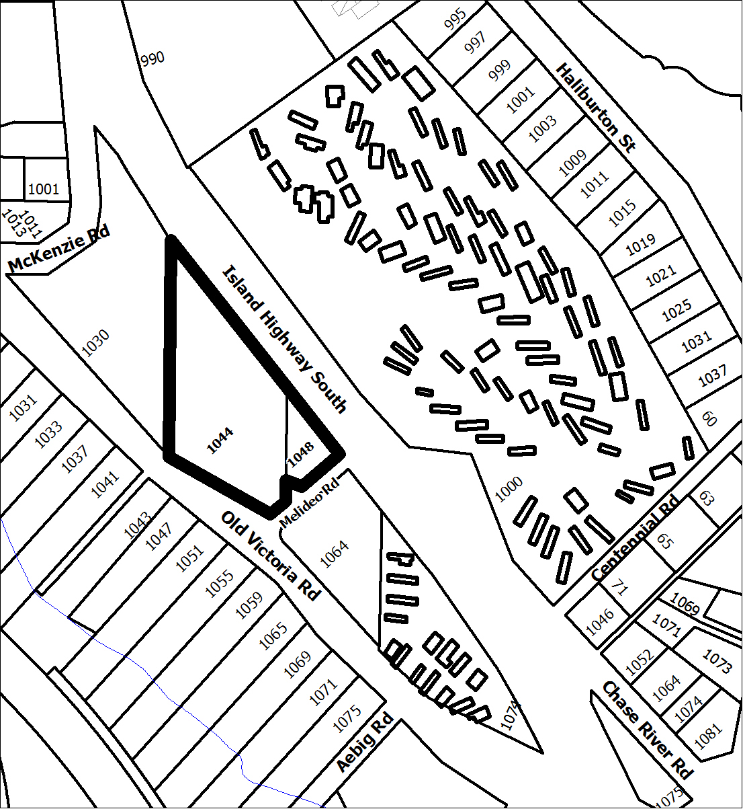

Industrial to
Light Industrial

Neighbourhood to
Light Industrial

SCHEDULE B

- Schedule C (The Chase River Neighbourhood Plan) of the “OFFICIAL COMMUNITY PLAN BYLAW 2008 NO. 6500” is amended as follows:

- Amending Schedule A-7.3 Chase River Neighbourhood by redesignating the subject properties known as:

1044 Old Victoria Road (Lot D, Section 1, Nanaimo District, Plan 630, Except Parts in Plans 3212 RW and 956 RW; PID 008 742 979)

and

1048 Old Victoria Road (Lot 1, Section 1, Nanaimo District, Plan 12119, Except Part in Plan 3212 RW; PID 004 963 067)

from Neighbourhoods to Service Industrial Enterprise Area.
Chase River Neighbourhood Plan
Redesignate from
Neighbourhoods to
Service Industrial Enterprise Area

